Subject: New Health Benefit: Livongo is Now Available at No Cost to You

[Salutation line] [First Name]},

We’re excited to announce the launch of Livongo’s Chronic Condition Management Plus program, a health benefit offered at no cost to you. Livongo helps you manage diabetes, prediabetes, hypertension, and other health goals like managing weight, stress, and more.

Eligible Members: The program is available at no cost to you and your family members covered on your medical plan and meets program requirements.

The benefits you get with Livongo include:
- Top technology: Receive advanced health devices to help you manage your health at home and on the go.

- Convenient tracking: Livongo devices automatically save readings to a private, easy-to-use app. You can also track meals and steps — all in one place.

- Personalized insights and action plan: Get tips to help you learn and improve, and a personalized action plan to help reach your goals.

- Virtual expert coaching: Friendly expert health coaches can offer guidance on managing blood sugar, blood pressure, healthy eating, exercise, and more. Connect virtually whenever it’s convenient for you.

- Important benefits at no cost to you: Livongo offers even more program-specific benefits that help make it easier to manage your health:

Diabetes Management | Blood Pressure Management | Healthy Living & Diabetes Prevention
Connected blood glucose meter  Unlimited strips  Mental health support & more  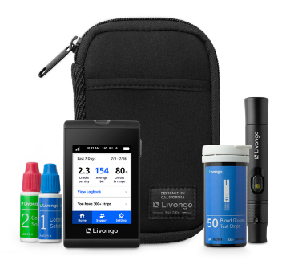  Program may also include connected blood pressure monitor, smart scale, and/or cholesterol support, depending on your health goals | Connected blood pressure monitor  Personalized tips  Mental health support & more  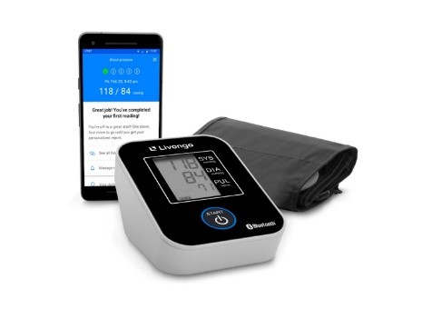  Program may also include connected scale and/or cholesterol support, depending on your health goals | Connected scale  App-guided lessons  Guidance on healthy habits & more  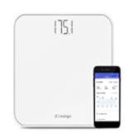  Program may also include connected blood pressure monitor and/or cholesterol support, depending on your health goals

To Learn More or Join: Be.Livongo.com/EVHC/register

If you have any questions about these programs, please visit the Livongo website or call Livongo Member Support at (800) 945-4355 and mention the registration code EVHC.

Thanks,
-[HR NAME]

