**Partner Role Access**

Partner Registration 2

Registration Process 3

Member Search 8

Additional Claim Details 10

Authorizations Page 13

At the member level 14

At the claim level 15

Claim Form Images 17

Claim Investigations Page 19

At the member level 20

At the claim level 22

Correspondence Page 25

At the member level 26

At the claim level 28

Grievances & Appeals Page 31

At the member level 32

At the claim level 34

Provider Details 37

# Partner Registration

Partner registration is only required for new users who have not previously created a client level portal account for EVHC.

Please note – at this time, Partner Registration is tied to the Luminare Health look. Once the Partner user is logged in, the appropriate EVHC branding will display.

To register, go to this [link](https://web9.hlthben.com/apps/um/login/partner.jsp).

(<https://web9.hlthben.com/apps/um/login/partner.jsp>)

## Registration Process

You will first need to verify your email address before proceeding. Enter your email address and click

An email will be sent to the email address you have entered.

Enter the verification code, from the email, and click 

Click once the code has been verified.

You will next be prompted to enter your user information.

Complete all of the fields and click  to continue.

You will next be prompted to re-enter your password and then click 

The final step of the partner registration process is to enter the Partner Client Name associated with your account.

Enter “Evolution” and click

After you have completed your registration, your account will be reviewed and appropriate permissions will be assigned.

# Member Search

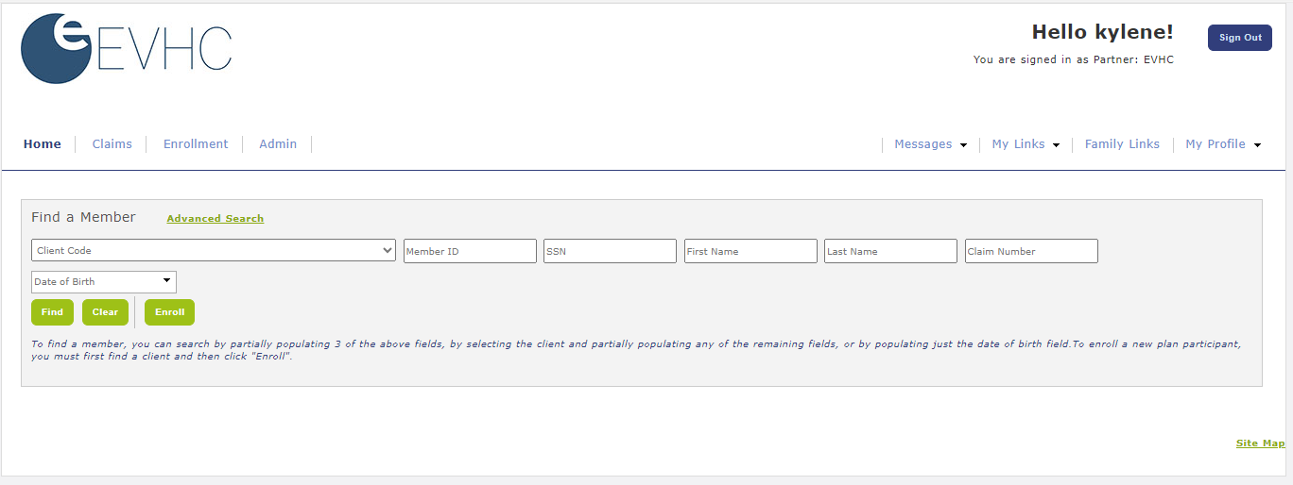

The Partner role allows you to search for members across all of the clients you have access to view.

Search by:

* Client drop down list – if you select just a single client, you can view the client dashboard
* Member ID – entering just a member ID will find members who match that search criteria
* Claim Number – entering just a claim number will find members with claims matching the search criteria
* Date of Birth – entering just a date of birth will find members who match that search criteria
* For all other searches, you can provide partial information for any 3 fields to find members who match

This is an example of searching by date of birth and the search results that display.

When search results display, showing multiple members to choose from, you can sort each column by the column heading to help narrow down your search.

To select a member, click the link on the member’s name. Your dashboard view, and all pages, will update to reflect information specific to the found member.

# Additional Claim Details

From the **Claims🡪 Claims** page, click  to access additional information about the claim.

Note – if you know the claim # you can easily search for the claim by entering just the claim # in the member finder!

Within the **Claim Details** section additional links are available to allow you quick and easy access to all of the information related to the claim.

To view the **Additional Claim Details** associated with this claim, click 

Next, a popup will display providing the additional details.

# Authorizations Page

You can access Authorization information in two ways –

* At the overall member level – this will give you access to all of the authorizations that exist for the family of the found member
* At the claim level – this will give you access to the authorizations tied to a specific claim and is viewable from the claims page

## At the member level

Once you have found a member, go to **Claims 🡪 Authorizations**.

If authorizations exist for the family, they will display in the **Authorization Summary** section of the page.

To access additional information about the authorization, click corresponding **Authorization #**.

## At the claim level

From the **Claims🡪 Claims** page, click  to access additional information about the claim.

Note – if you know the claim # you can easily search for the claim by entering just the claim # in the member finder!

Within the **Claim Details** section additional links are available to allow you quick and easy access to all of the information related to the claim.

To view the **Authorization Details** associated with this claim, click 

A popup will display providing the additional details.

# Claim Form Images

From the **Claims🡪 Claims** page, click  to access additional information about the claim.

Note – if you know the claim # you can easily search for the claim by entering just the claim # in the member finder!

Within the **Claim Details** section additional links are available to allow you quick and easy access to all of the information related to the claim.

To view the **Claim Form** associated with this claim, click 

This will display the actual claim form received in a new browser tab window.

# Claim Investigations Page

You can access Claim Investigation information in two ways –

* At the overall member level – this will give you access to all of the claim investigations that exist for the family of the found member
* At the claim level – this will give you access to the claim investigations tied to a specific claim and is viewable from the claims page

## At the member level

Once you have found a member, go to **Claims 🡪 Claim Investigations**.

If claim investigations exist for the family, they will display in the **Claim Investigations Summary** section of the page.

To access additional information about the claim investigation, click ****.

Additional details about the claim investigation will expand and display in the **Claim Investigations Detail** section.

## At the claim level

From the **Claims🡪 Claims** page, click  to access additional information about the claim.

Note – if you know the claim # you can easily search for the claim by entering just the claim # in the member finder!

Within the **Claim Details** section additional links are available to allow you quick and easy access to all of the information related to the claim.

To view the **Claim Investigation Details** associated with this claim, click 

Next, a popup will display providing the additional details.

If more than one claim investigation exists for this claim, you will be presented with a list.

Click to access the appropriate claim investigation detail record. 

# Correspondence Page

You can access Correspondence information in two ways –

* At the overall member level – this will give you access to all of the correspondence that exists for the family of the found member
* At the claim level – this will give you access to the correspondence tied to a specific claim and is viewable from the claims page

## At the member level

Once you have found a member, go to **Claims 🡪 Correspondence**.

If correspondence exists for the family, they will display in the **Correspondence Summary** section of the page.

To access additional information about the correspondence, click ****.

Additional details about the correspondence will expand and display in the **Correspondence Detail** section.

## At the claim level

From the **Claims🡪 Claims** page, click  to access additional information about the claim.

Note – if you know the claim # you can easily search for the claim by entering just the claim # in the member finder!

Within the **Claim Details** section additional links are available to allow you quick and easy access to all of the information related to the claim.

To view the **Correspondence Details** associated with this claim, click .

Next, a popup will display providing the additional details.

If more than one correspondence exists for this claim, you will be presented with a list.

Click to access the appropriate correspondence detail record. 

# Grievances & Appeals Page

You can access Grievances & Appeals information in two ways –

* At the overall member level – this will give you access to all of the grievances & appeals that exist for the family of the found member
* At the claim level – this will give you access to the grievances & appeals tied to a specific claim and is viewable from the claims page

## At the member level

Once you have found a member, go to **Claims 🡪 Grievances & Appeals**.

If grievances & appeals exist for the family, they will display in the **Grievances & Appeals Summary** section of the page.

To access additional information about the grievances & appeals, click ****.

Additional details about the grievances & appeals will expand and display in the **Grievances & Appeals Detail** section.

## At the claim level

From the **Claims🡪 Claims** page, click  to access additional information about the claim.

Note – if you know the claim # you can easily search for the claim by entering just the claim # in the member finder!

Within the **Claim Details** section additional links are available to allow you quick and easy access to all of the information related to the claim.

To view the **Grievances & Appeals Details** associated with this claim, click . 

Next, a popup will display providing the additional details.

If more than one grievance & appeals exists for this claim, you will be presented with a list.

Click to access the appropriate grievances & appeals detail record. 

# Provider Details

From the **Claims🡪 Claims** page, additional information about a provider is available for each claim.

Within the Claim Summary section, click the Provider link and a popup will display with additional provider details.

Note – if you know the claim # you can easily search for the claim by entering just the claim # in the member finder!

